Math 4 Name_______________________________

**1-8 Arithmetic and Geometric Series** Date________

*In this investigation, you will be working towards the following learning goals:*

*I can evaluate arithmetic or geometric series*

*I can solve problems involving arithmetic and geometric sequences and series*

**Review:** a. Given the sequence , find 

b. Given the sequence , find 

A **series** is the sum of all or part of a sequence. A series is represented symbolically as follows:

If is a sequence, then the series (sum) is represented 

If the number of terms added is *finite*, then the term is (not surprisingly) called a **finite series**. If the number of terms added is *infinite*, the resulting series is called an **infinite series**. If the terms are in an arithmetic sequence, then the series is an **arithmetic series.** In certain cases, that you can add an infinite (never ending) number of terms in an series and find the sum. Think about that – *this is exciting mathematics!*

**The (supposed) story of Carl Gauss…**

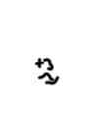Formula for the sum of an Arithmetic Series:

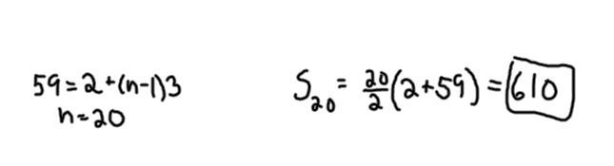

**Example 1** Find the sum of the following arithmetic sequence: 

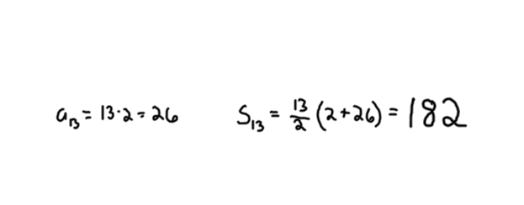**Example 2** Evaluate the following: 

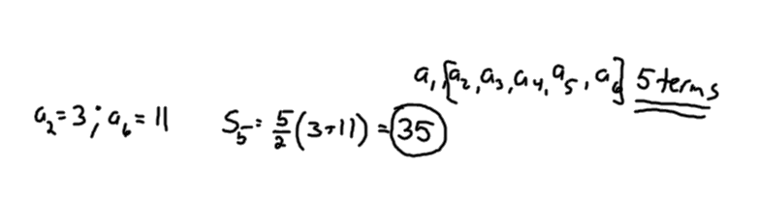

**Example 3** Evaluate the following: 

**Use the formulas above to find the sum of the following arithmetic sequences:**

1.  2. 

**Find the indicated sum of the following arithmetic series:**

3.  4. 

5.  6. 

7. To build up endurance, you start an exercise program in which you exercised 30 minutes the first day, 34 the next day, 38 minutes the third day, 42 minutes the fourth day, and so on, each day extending your exercise time by 4 minutes. If you continue at this rate, ending at 2 hours and 30 minutes, what is the total time you spend exercising?

Much like the sum of an arithmetic sequence is called an arithmetic series, a **geometric series** is the sum of a geometric sequence. The sum, , of the first *n* terms of a the sequence is called the ***n*th partial sum**, and is written . Notice that the part in the parenthesis is simply the formula for a geometric sequence, and the sigma tells us to sum the terms.

Just as there is a formula for an arithmetic series, there is a form for a geometric series.

***The sum  of the finite geometric series with first term  and constant ratio  is given by:***



**Example 4** Evaluate  . Start by identifying the following:

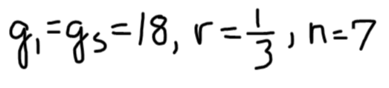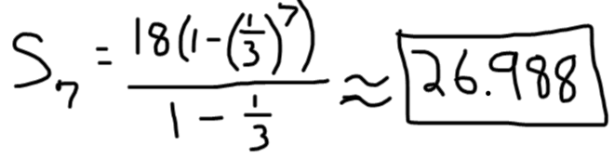

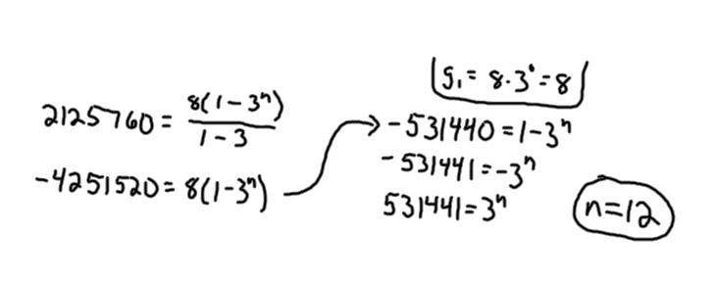**Example 5** How many terms of the geometric sequence  will be needed so that the sum of the sequence (geometric series) is 2125760?

8. Evaluate . 9. Evaluate 

10. A classic children’s toy is stackable cups. The cups are made so that the cups will fit successively one inside the next (see picture below). In order for the cups to stack properly, each cup must be  the height of the taller cup. If the height of the tallest cup is 10 cm, what is the combined height of all the cups (there are 7 cups total).

11. The maximum number of natural (biological) ancestors that you could have are 2 parents, 4 grandparents, 8 great-grandparents, and so on. Assuming that no one appears twice in your ancestral tree, in the last *n* generations you have  natural ancestors, where . How many generations must you go back before you have a million natural ancestors, assuming that no one appears twice?

12. Find the partial sum of the following series: 

13. Find the partial sum of the following series: 

14. Find the following partial sums:

a.  b.  c. 

A series in which we sum the terms from 1 to is called an **infinite series.**

The **sum** of the infinite series is the limit of the sequence of partial sums of the series, *provided the limit exists and is finite*.

What this definition means is that the sum of an infinite series is the limit of the infinite series. If exists, then the series is **convergent** and its sum is . If the limit does not exist, then the series is **divergent**.

**Theorem:**

Consider the infinite geometric series with .

a. If |*r|*< 1, the series converges and 

b. If |*r|*> 1, the series diverges.

Decide if the following infinite geometric series converge or diverge. If they converge, find the sum.

15.  16. 

17.  18. 

19. Because of air resistance, the length of each swing of a certain pendulum is 95% of the length of the previous swing. If the first swing has a length of 40 cm, find the total length the pendulum will swing before coming to rest.